Daniel Fryer
Assignment 5.2 Movies setup
2/6/2026
Script Ran:
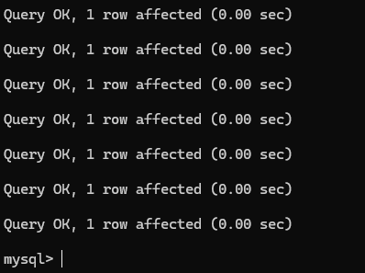
Show movies tables
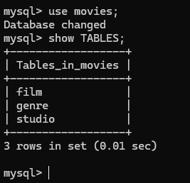
Python script ran:
